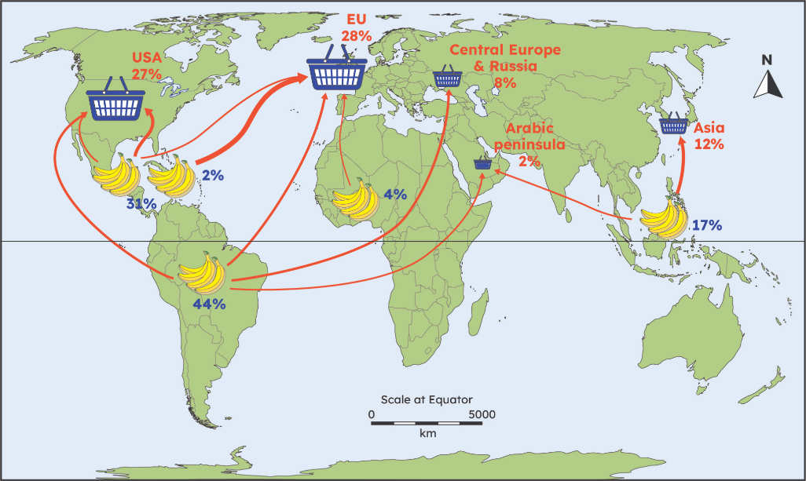
Year 6 Knowledge Organiser
What is global trade and why does it occur?

Example of global trade for bananas.
By the end of this unit, I will know:
- what trade, global supply chain and ethical trading mean.
- that countries import and export different commodities based on their physical and human geography.
- that imports are what a country brings in and exports are what a country sends out.
- some UK import and exports and how this differs to other countries.
- that ethical trading improves the lives of people selling products and are better for the environment too.
- that products have a trade route and can give an example
- that a food mile refers to how far a food item has travelled and the effect this has on the environment.
- that products can be transported via plane, boat, train and lorries.
The three stages of production.
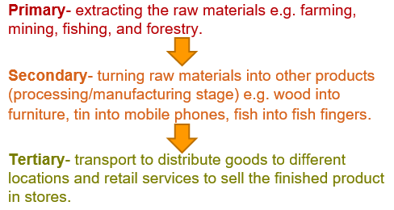
UK Exports.
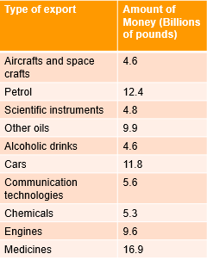
What should I already know?
Coastal areas are important in trade (Year 3).
Different countries have different biomes and that affects the weather, climate and landscape and what the country can grow or make (Year 3).
Scandinavia’s landscape affected what they traded (Year 4).
Basingstoke Canal, the River Thames and rivers are used to transport goods (Year 4).
What food are produced and exported from rainforests (Year 5).
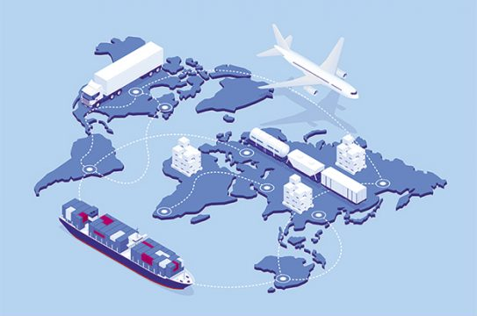

Modes of transport for trade.

I need to know:
- Trade has changed over time, from the Stone Age (Year 3) throughout the 17th Century to the 21st Century. People traded goods across much shorter distances compared with today as places were not as accessible or well linked by communications and modern transport methods. In the 17th Century, trade via oceans became possible. Over time transport, technology, and communication systems have improved and become more advanced. Improvements have meant that nowadays trade is able to occur on a global scale.
- The physical geography of a country determines whether foods can or cannot be grown there.
- The raw materials found in a country will affect what they export or import.
- The cost of production affects where a product is made.
- Manufactured goods go through a global supply chain from source to sale – one singular item could have different parts produced in different countries that have to come together before they can be sold.
- Fair trade is about the welfare of people producing commodities, such as factory conditions, fair wages, distribution of profit and better working conditions and rules to protect the safety of the workers.
- Food miles relate to how far a food item has travelled. The further an item has travelled the worse it is for the environment and carbon footprint. If people bought local and seasonal food it would help.
- There are 3 stages of production that manufactured goods go through – primary, secondary and tertiary (see flowchart on page 1).
- UK's main imports include machinery, vehicles, and mineral fuels, while its main exports are cars, mechanical power generators, and pharmaceutical products. The UK also exports services such as business and financial services.

Key vocabulary
Commodity: is something that is bought and sold, like a product or raw material.
Distribution: refers to the way something is spread out or arranged over a specific geographic area.
Ethical: being fair, honest, and kind to others and making decisions that are morally good.
Export: selling goods and services to another country.
Food miles: are the distance food has travelled to get to your plate.
Import: buying goods or services from another country.
Manufactured: something that has been made or created, especially in a factory or using machinery.
Production: the process of making or growing something.
Raw materials: are natural things that haven't been changed or processed yet. They are found in nature, just as they are, before people do anything to them.
Supply chain: is the whole journey a product or service takes from where it starts (like a farm or factory) all the way to you, the customer.
Trade services: buying and selling things.


When will I find out more?
- I will find out about looking after and protecting the environment further in Year 6.

