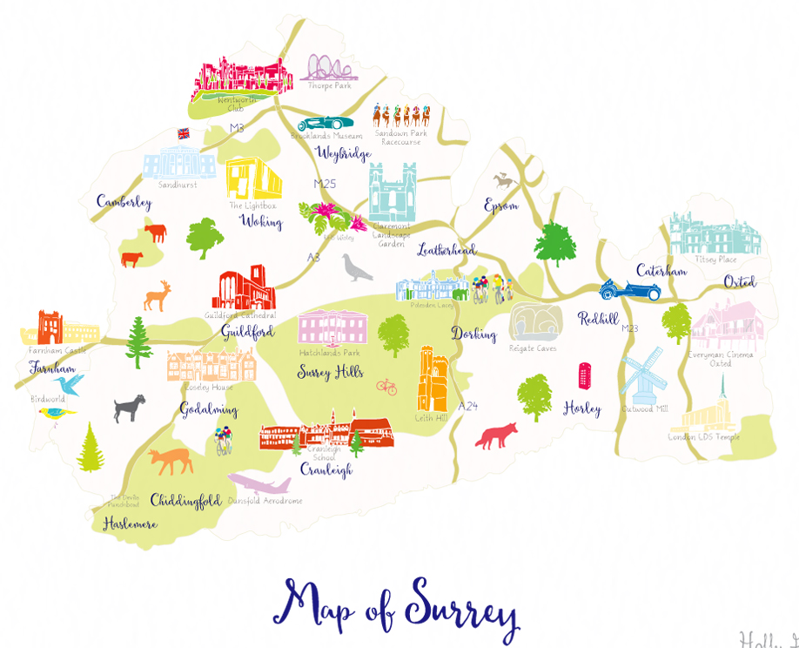
Map indicating some landmarks of Surrey.

Year 5 Knowledge Organiser
Is our local region fit for purpose?

By the end of this unit, I will:
- know how the needs of our population are met by the local (Woking) and regional area (Surrey).
- be able to locate key physical and human features of our local region e.g. Brooklands Museum, Horsell Common, Mercedes Benz World, Basingstoke Canal and the benefits of them.
- understand human and physical similarities and differences of Surrey and other UK locations in relation to tourism and attractions.
- know how a 6 figure grid reference work and use them.
- be able to explain what a thematic map is and why someone might want to use/ create one.
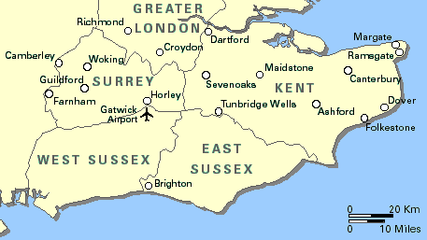
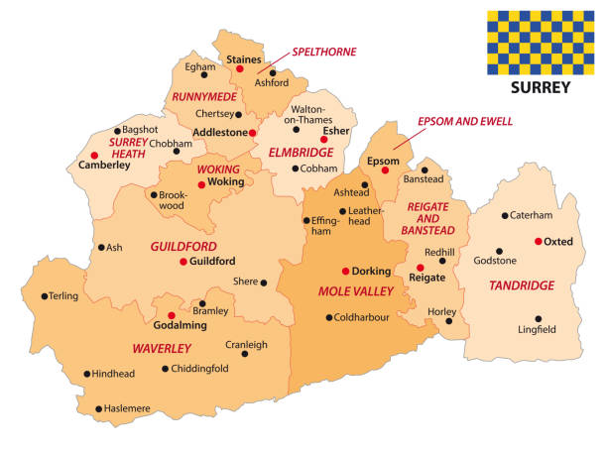

What should I already know?
- The surrounding towns and counties of West Byfleet (Year 3).
- The countries, capital cities and seas of the United Kingdom (Year 3).
- The function and benefits of the Basingstoke Canal and River Thames (Year 4).

West Byfleet is located here, in Surrey (county), within the South East of England.

I need to know:
- The human features of Surrey include shops, houses, park, schools, doctors, hairdressers, roads, attractions, museums, train stations and paths.
- The physical features of Surrey include fields, parks, Surrey hills, Basingstoke Canal, River Wey and River Thames.
- The local landmarks and attractions of our local area include Brooklands Museum, Horsell Common, Mercedes Benz World and Basingstoke Canal.
- The wider Surrey landmarks include Hampton Court, London Eye, River Thames, Wimbledon, Natural History museum, Buckingham Palace and St James’ Park etc.
- The physical and human features of our local area and Surrey are different to other towns and counties e.g. West Wittering (a coastal town).
- That a survey can provide an opinion of the population and can be used to collect data.
- Whether our local area is fit for purpose to meet the needs of the population e.g. does it have the things needed to live healthy and happy lives e.g. food, housing, schools, freedom, equality, love etc.
- How to use an OS map to create a thematic map of how the needs of a population are being met.
- How to create a six-figure grid reference to locate key features of the landscape.

Key Vocabulary
Culture: the way a group of people live, including their customs, beliefs, traditions and ways of expressing themselves.
International: things that involve or relate to more than one country.
Landmark: a feature or structure around the world that is easily recognised or unique. They can be natural or man-made.
National: things that relate to or involve the entire country.
Population: the number of people living in a particular place.
Regional: an area with common characteristics, either physical (like mountains or rivers) or human (like language or culture).
Rural: the countryside, or areas away from towns and cities.
Six-figure grid reference: a system used on maps to pinpoint a location with more precision than a four-figure grid reference.
Thematic Map: a map that focuses on a specific topic or theme. It uses symbols and colors to represent data related to that theme e.g. rainfall.
Urban: cities and towns where many people live and work.

When will I find out more?
- In Year 6 I will link my learning to the physical and human landmarks of North and South America.

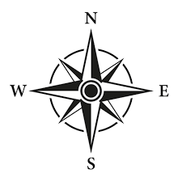
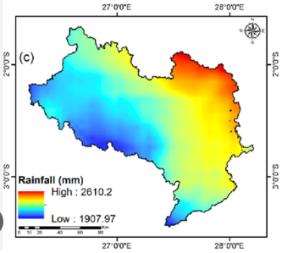
Compass
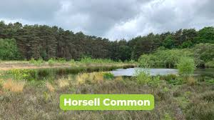
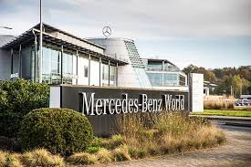
Thematic Map
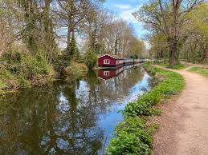
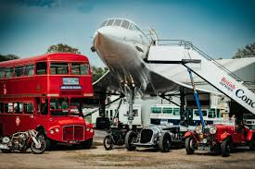
Local Landmarks

