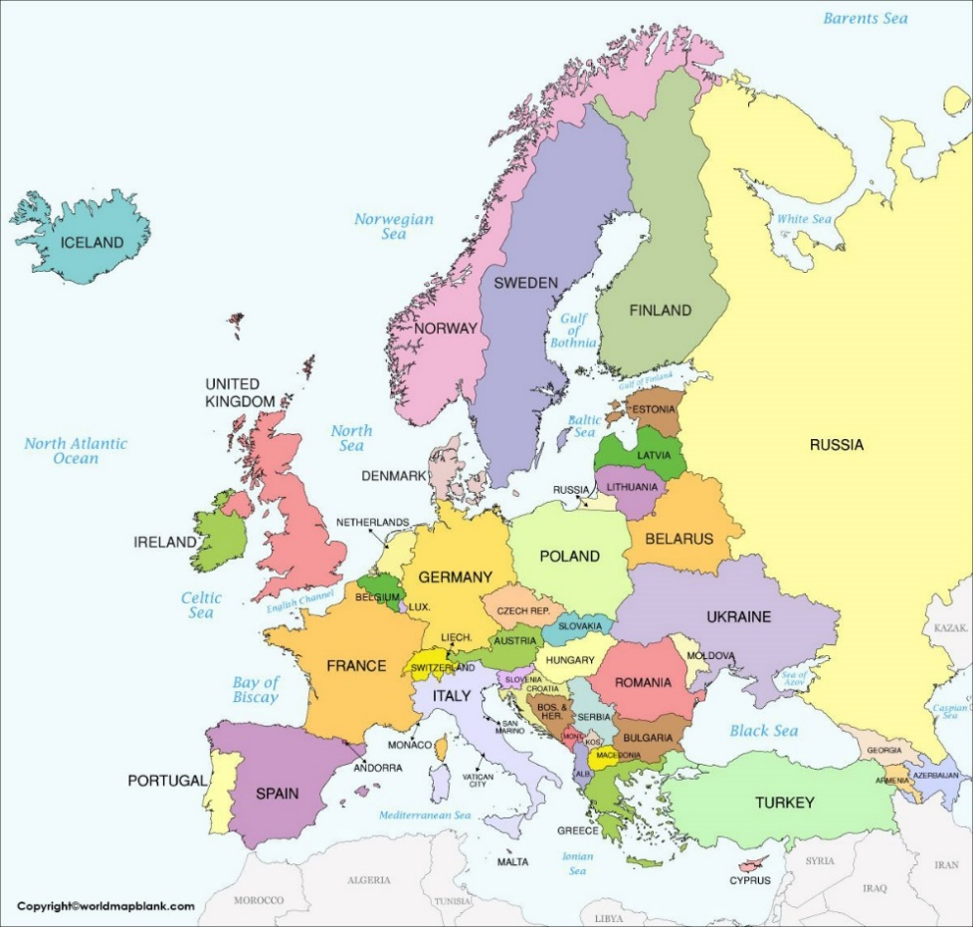
Scandinavian countries and seas circled
Year 4 Knowledge Organiser
What is it like in Scandinavia?

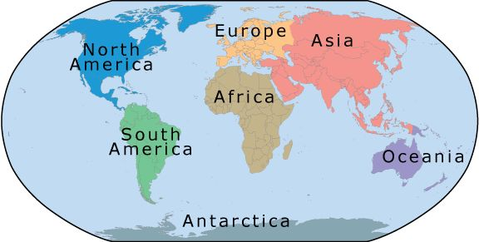
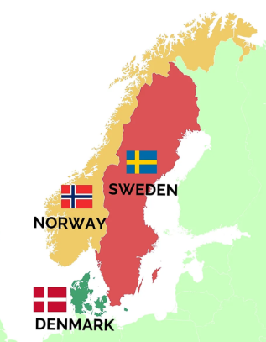

By the end of this unit, I will know:
- where the Arctic Circle, Polar Regions and Europe is on a map.
- the name and location of the Scandinavian countries: Norway, Denmark and Sweden.
- the physical and human similarities and differences between the Scandinavian countries and the UK.
- the physical features of glaciers and fjords.
- about the natural phenomenon of the Northern Lights.
- how the physical features of a country effect the imports and exports of the area e.g. Scandinavia – farming and fish.
Scandinavian country flags

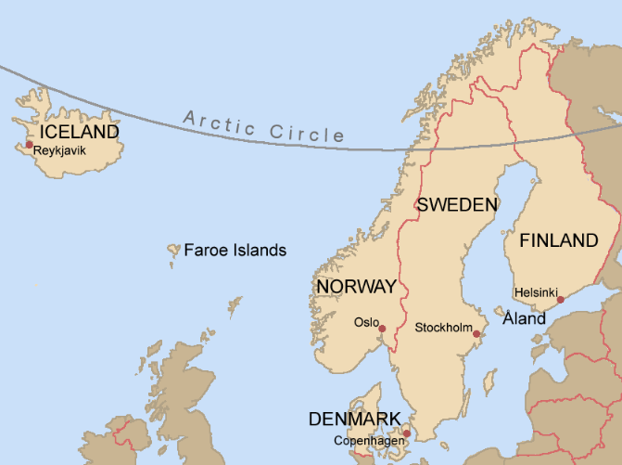
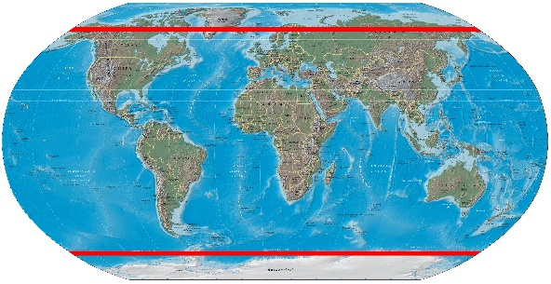
What should I already know?
- The world is divided into 7 continents.
- Areas have physical and human geographical features (Year 3)
- Countries have different regions, climates and biomes (Year 3).
Polar Regions – North and South Pole
Arctic Circle – above the line drawn

Key vocabulary
Agriculture: is another word for farming. It includes both growing and harvesting crops and raising animals, or livestock.
Arctic Circle: is a special imaginary line around the top of our planet, Earth.
Fjords: a long, narrow body of the sea that has steep cliffs rising up on each side of it.
Glacier: is a huge, slow-moving river of ice and snow.
Midnight Sun: Places in the far north of countries like Norway, Finland and Sweden that have daylight all day long, in the summer months.
Natural Phenomenon: an event or process that occurs naturally in nature, without human influence.
Nordic: belonging to or relating to Scandinavia, Finland, or Iceland.
Northern Lights: is the name given to the natural colourful lights that can appear in the night sky over the northern hemisphere.
Polar Regions: area around the North Pole or the South Pole.
Renewable Energy: using power from things in nature that never run out, like sunlight, wind, water and heat from the Earth.
Tundra: a type of biome found in some of the coldest regions in the world. It is a vast, frozen and treeless landscape.
I need to know:
- The Scandinavian countries are Norway, Denmark and Sweden and parts of Norway and Denmark enter the Arctic Circle. They are near to the North Pole.
- The summers are light and the temperatures are mild. Above the Arctic Circle you can experience the Midnight Sun. Much of the Nordic countries are covered in snow during winter; although snow is much rarer in the south and along the coast.
- During winter you will experience the dark season; above the Arctic Circle there will be a period without daylight increasing the chances of seeing the Northern Lights.
- The landscape is characterized by diverse features including mountains, fjords, glaciers, archipelagos and varied climates.
- Norway is known for its rugged mountains and deep fjords and glaciers, while Sweden features a mix of mountains, forests, and lakes. Denmark is generally flat with a sandy coastline.
- Scandinavia’s climate and physical geography, near water, is very important to the countries for farming, fishing, tourism and exports.
- The people of Scandinavia have a high quality of life and most people in Scandinavia choose to settle near the sea or lakes.
- People in Scandinavia value their unspoiled country and work hard to protect it. They avoid pollution by recycling waste materials and using renewable energy. Electricity is generated by wind power in Denmark and hydroelectric power across the whole region.

When will I find out more?
- I will find out more about rivers later in Year 4.
- I will find out more about mountains in Year 5
- I will find out more about trade in Year 6.

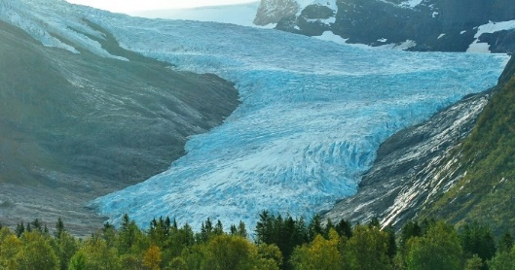
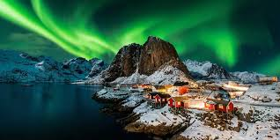
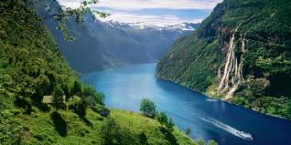

Glacier
Fjord
Northern Lights

