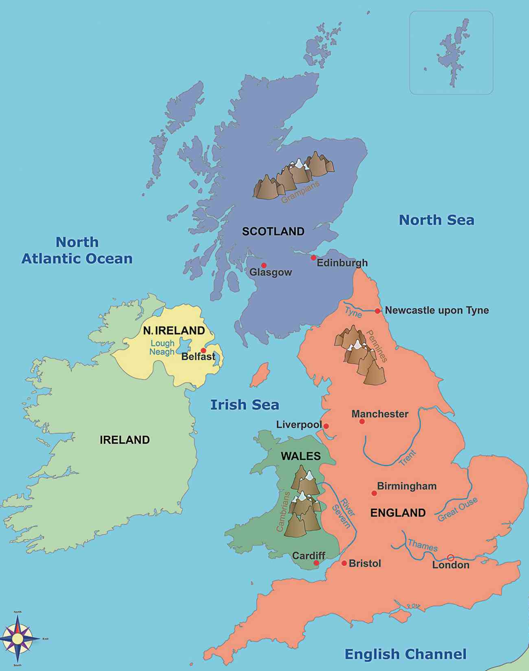
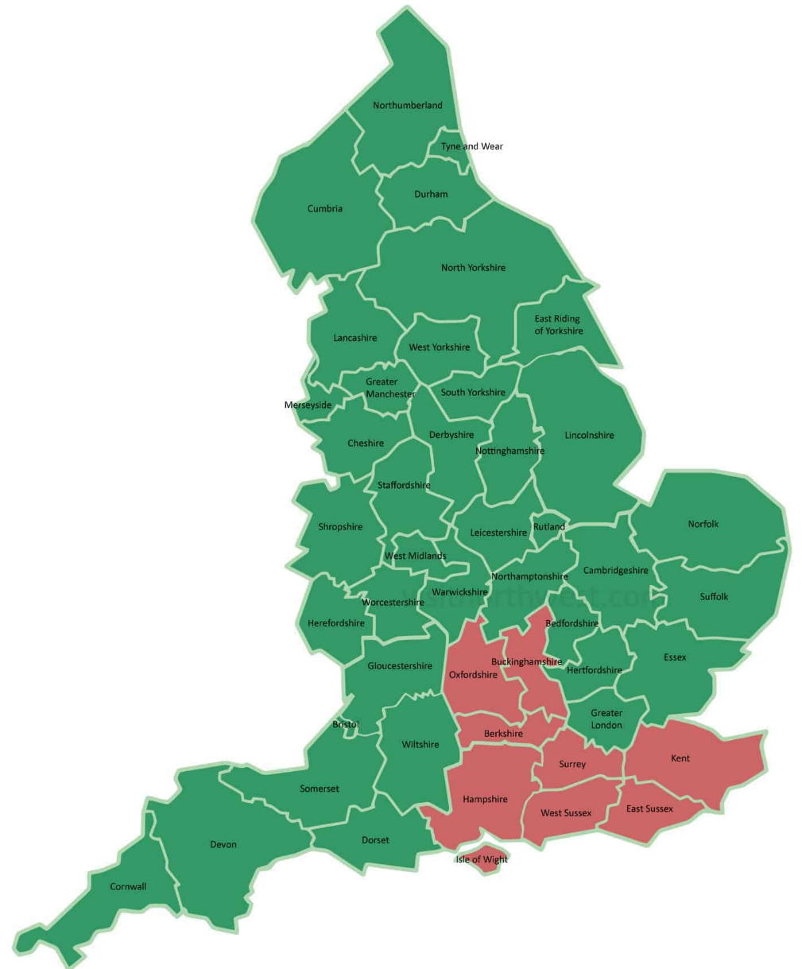
Map showing the counties of the UK.
Red counties indicate the South East of England

Year 3 Knowledge Organiser
What makes West Byfleet great?

By the end of this unit, I will:
- know where my school is located and name surrounding towns, cities and counties.
- be able to locate the capital cities of the UK – London, Edinburgh, Belfast and Cardiff
- be able to describe different types of settlements.
- identify some human and some physical features around school and the benefits of them.
- know how West Byfleet has changed over time and how it might change in the future and why.
- create a map to represent my local area and use a key.
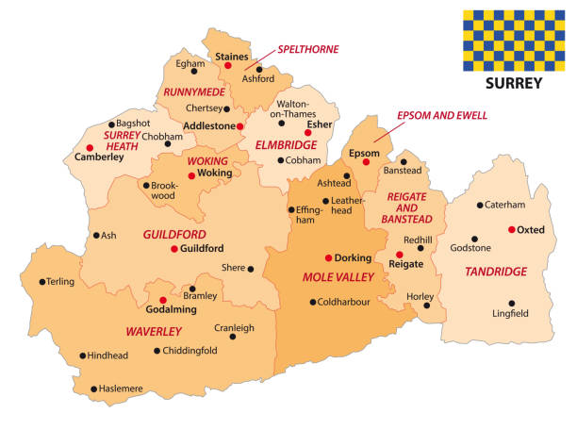
Map showing the UK, seas and Capital Cities (London, Edinburgh, Cardiff and Belfast)

What should I already know from KS1?
- The United Kingdom is made up of 4 countries. Each country has a capital city.
- The United Kingdom is surrounded by 4 seas.

West Byfleet is located here, in Surrey (county), within the borough of Woking.

I need to know:
- West Byfleet is in Surrey, in the South East of England. It is close to towns and counties shown on the maps on page 1.
- The capital cities of the United Kingdom (London – England, Cardiff – Wales, Edinburgh – Scotland and Belfast – Northern Ireland) and the location of each shown on the map on page 1.
- The term settlement and the definition of a village, town and city (see key vocabulary)
- The four main points on a compass are North, East, South and West.
- The human features of West Byfleet include: shops, houses, park, schools, doctors, hairdressers, roads, the train station and paths.
- The physical features of West Byfleet include: the recreation field by the school, Basingstoke Canal and the River Wey.
- West Byfleet has changed over time and the village was built around the central location of the train station.
- West Byfleet will continue to change into the future.
- How to represent West Byfleet on a messy map.
- How to illustrate changes to West Byfleet on an OS map.
Key Vocabulary
City: a place where many people live, with many houses, stores, businesses, etc., and which is bigger than a town.
Fieldwork: working outside to collect information.
Human features: things that have been made by humans e.g. shops, roads
Landscape: the visible features of an area of land e.g. human/physical
Location: a particular place or position.
Physical features: things that are natural e.g. hills, rivers, mountains
Recreation: activity done for enjoyment
Sketch map: a map with only a few details, usually drawn by hand
Town: an area with houses, schools and shops.
Village: a group of houses and associated buildings, larger than a hamlet and smaller than a town, situated in a rural area.

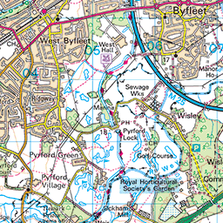
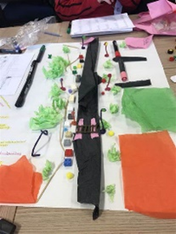
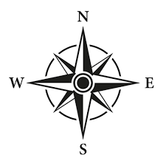
When will I find out more?
- In Year 4, I will learn about canals, and the Basingstoke Canal in particular as well as rivers in my local area.
- In Year 5, I will learn about the wider surroundings of West Byfleet, with a focus on Woking and the South East region. I will learn about the local landmarks of our area.
- In Year 6 I will link my learning to the types of land use and settlements that can be found in America.
OS Map
Messy Map
Compass

